TCP Demo Presentation/Plugin instructions

This TCP Demo presentation/plugin was built and tested on BA:Connected (1.7.10) and on a XD1034 (OS 8.4.16)

The plugin tcp-pluging-v3.brs was added to the presentation via Support Content > Script Plugin > Script Plugin Name > “tcp”

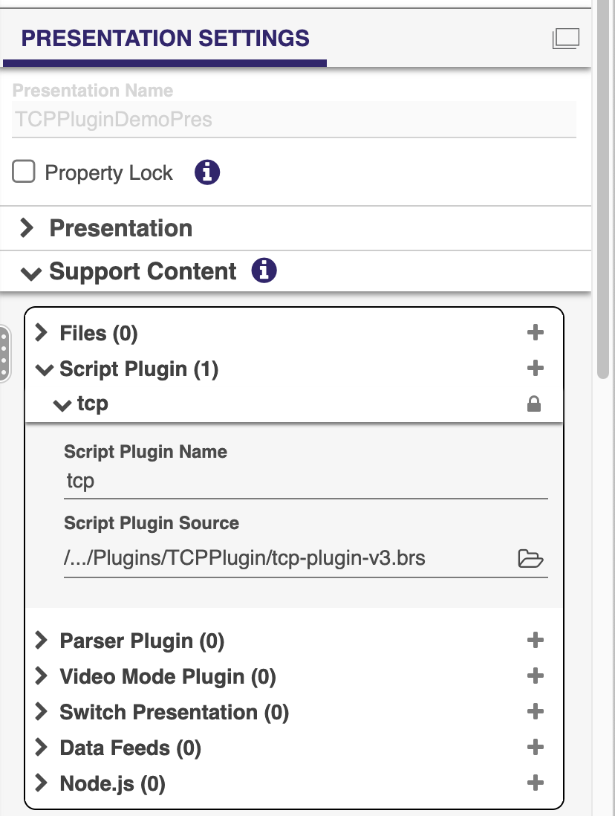

This Presentation/plugin allows the user to set the BrightSign player as a TCP server (i.e., the player will listen for TCP messages from a TCP client and move to a different state if a specific TCP input message has been defined in the BA:Connected presentation)

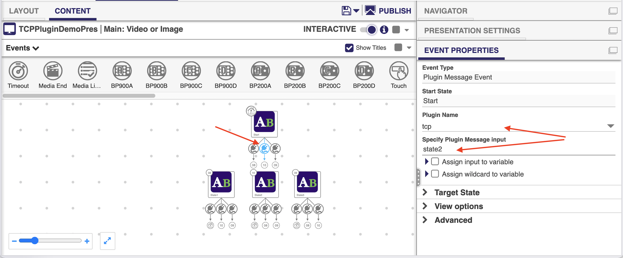

It is also possible to set the player as a TCP client (i.e., the player will be able to send a TCP message to a TCP server by specifying an Advanced command – “Send Plugin Message” > tcp > tcpmsg!theMessage).

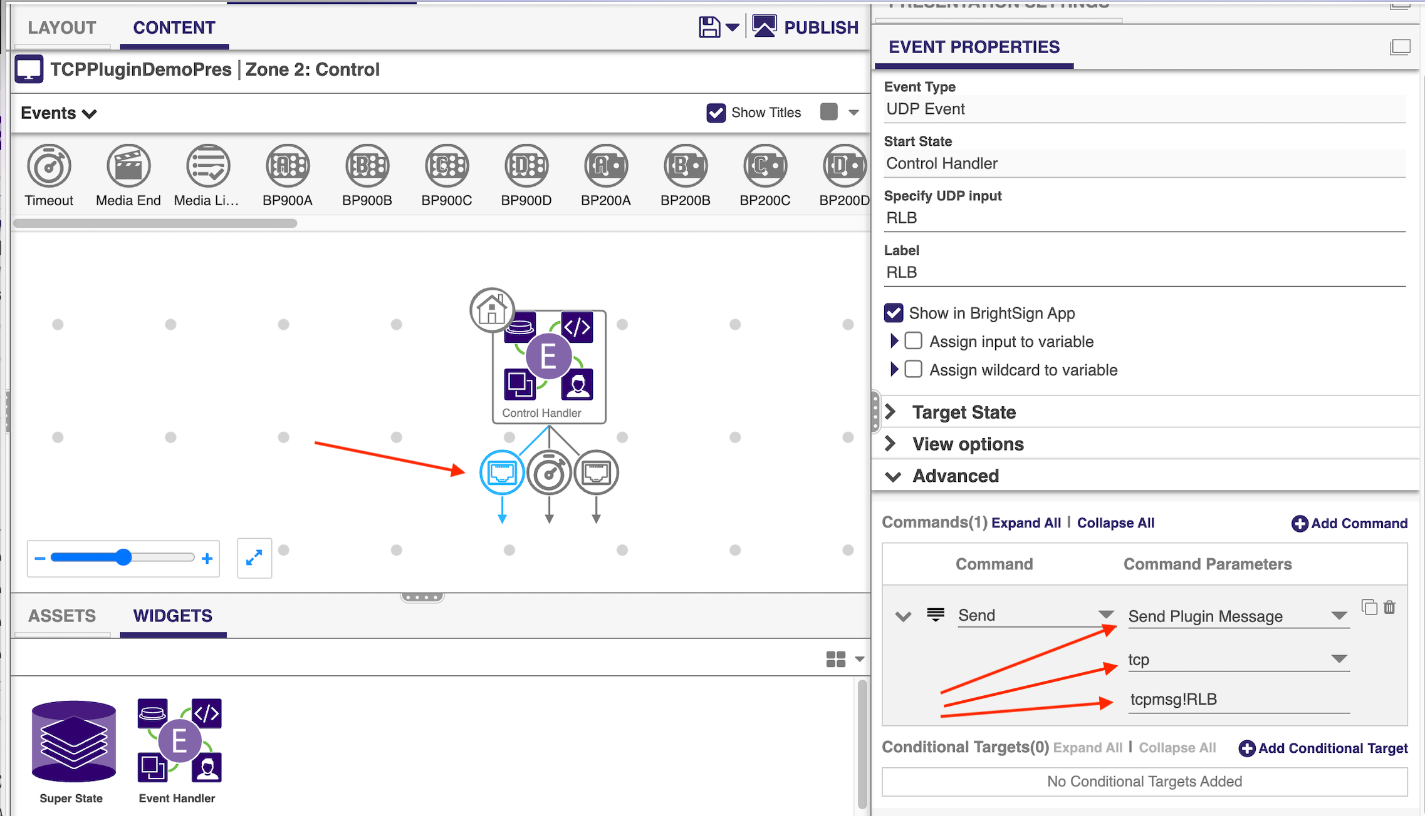

Plugin TCP configuration for the remote TCP server and the Local BS (BrightSign) server

Within the presentation Control zone there is an Event Handler (Control Handler) with a Timeout transition Event attached to it. This Timeout event has 2 Advanced commands attached to it.

The 1st Advanced command is a “Send Plugin Message” from the “tcp” plugin with a message that starts with “tcpremoteserver!”. This plugin message will need to be modified with your target remote TCP server IP Address and remote TCP server port Number in the format “tcpremoteserver!192.168.1.101!62286” . If you intend to send a TCP message to control a projector or some other device over TCP, you’ll ned to change that advanced command parameter so it matches your target device network settings.

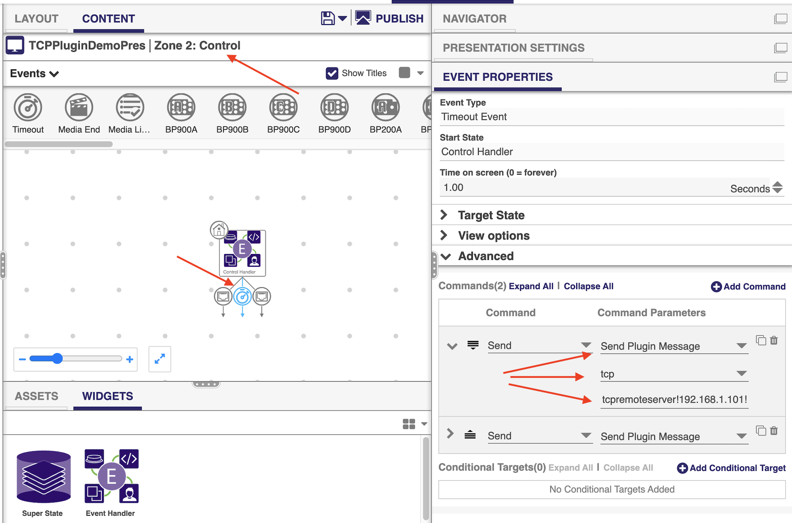

The 2nd Advanced command is a “Send Plugin Message” from the “tcp” plugin with a message that starts with “tcpbsserver!”. This plugin message will need to be modified with the TCP port Number that you want to communicate with the Brightsign player, in the format “tcpbsserver!5757” . If you intend to send a TCP message to control the Brightsign player over TCP you’ll need to modify that specific advanced command.

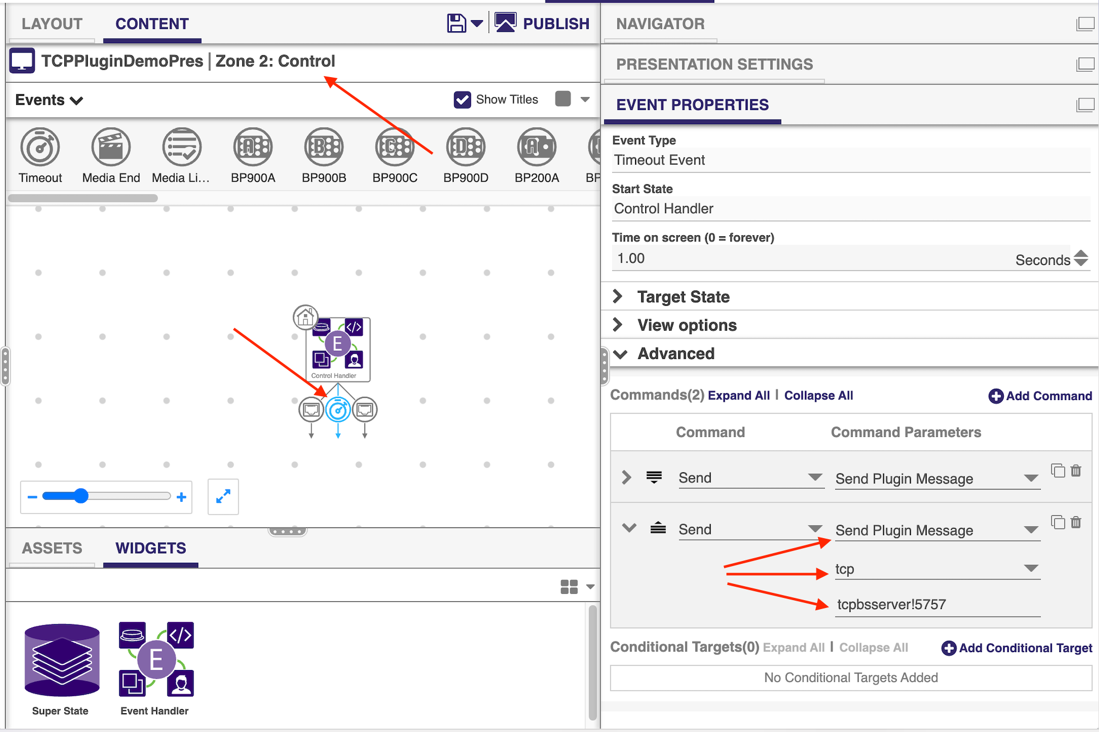

How to Listen for TCP messages from a TCP client

The presentation screen will display the IP addresses (wired/wifi) and ports defined/used for TCP communication for the Local BS TCP server and for the Remote TCP server, on the Start Live Text state.

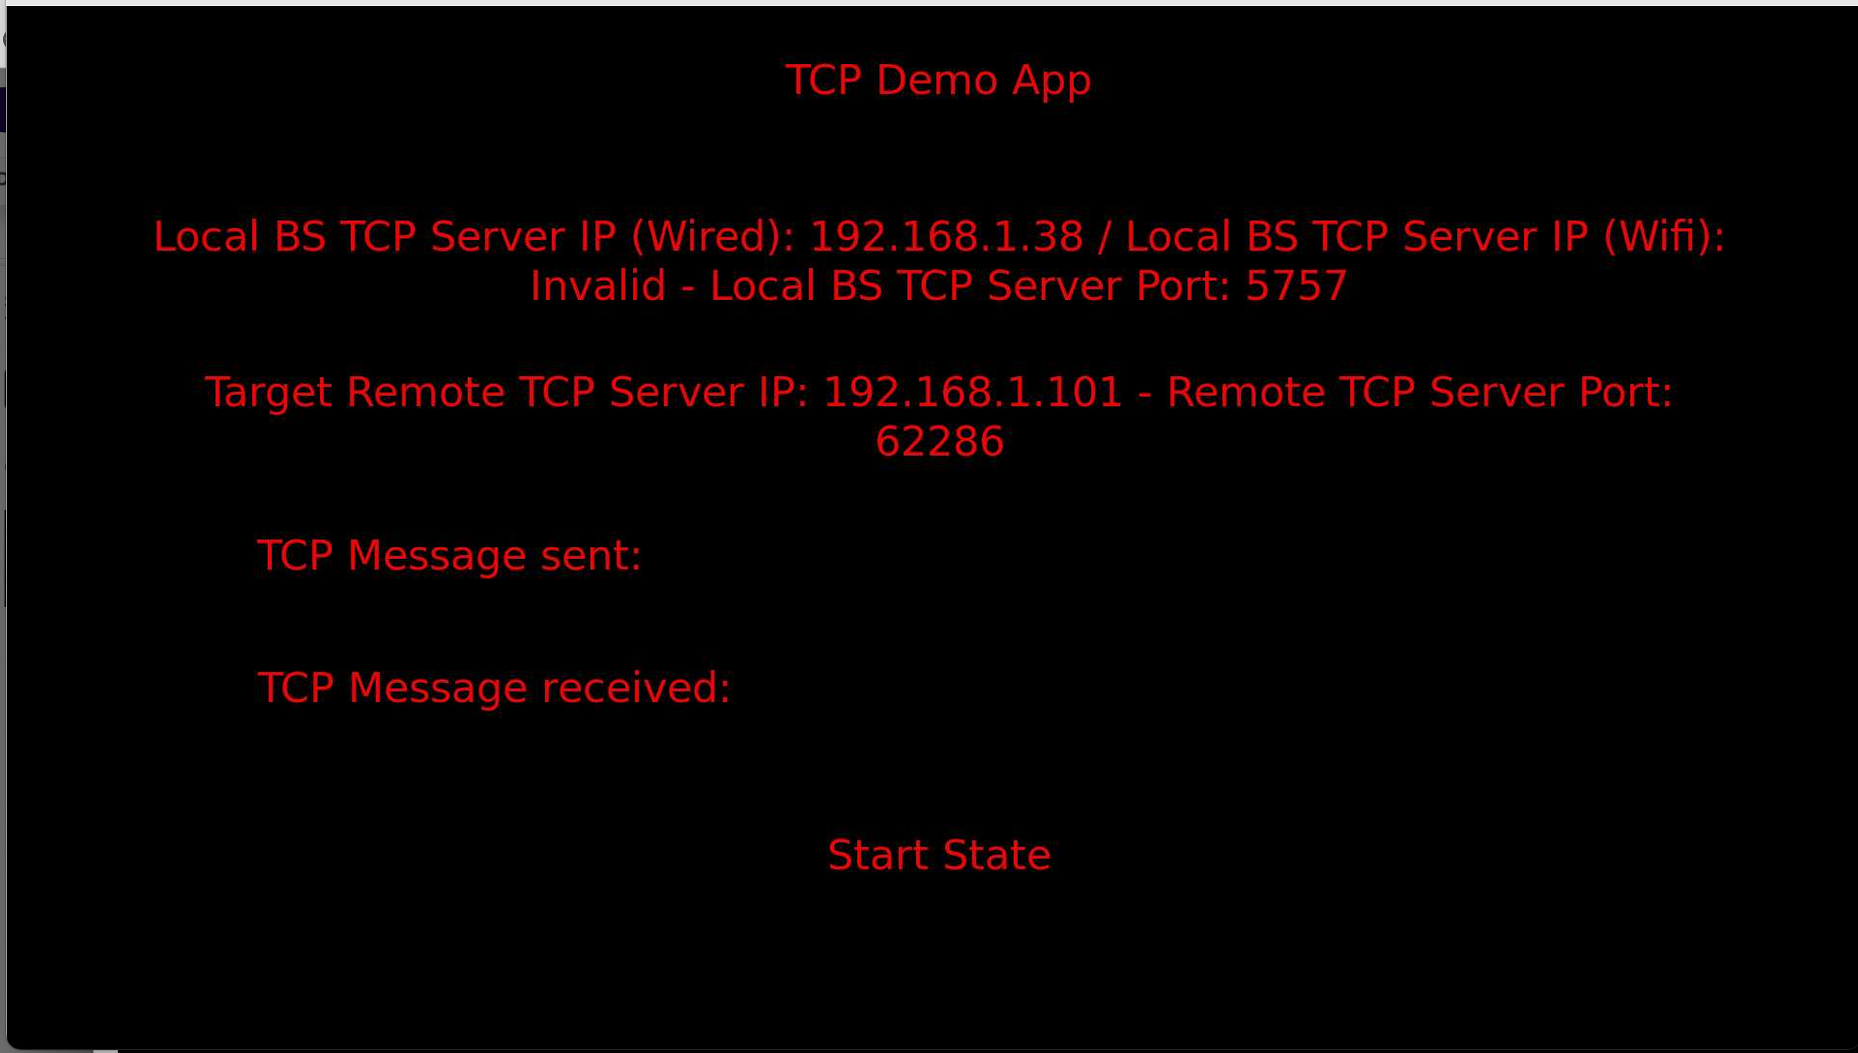

It is possible to test the application from your Windows/Mac machine using Hercules or Packet Sender to transition to different states defined in the BA presentation. Please note that each message must be sent with a carriage return (“<cr>” in Hercules or “\r” in Packet Sender)

Hercules (Windows)

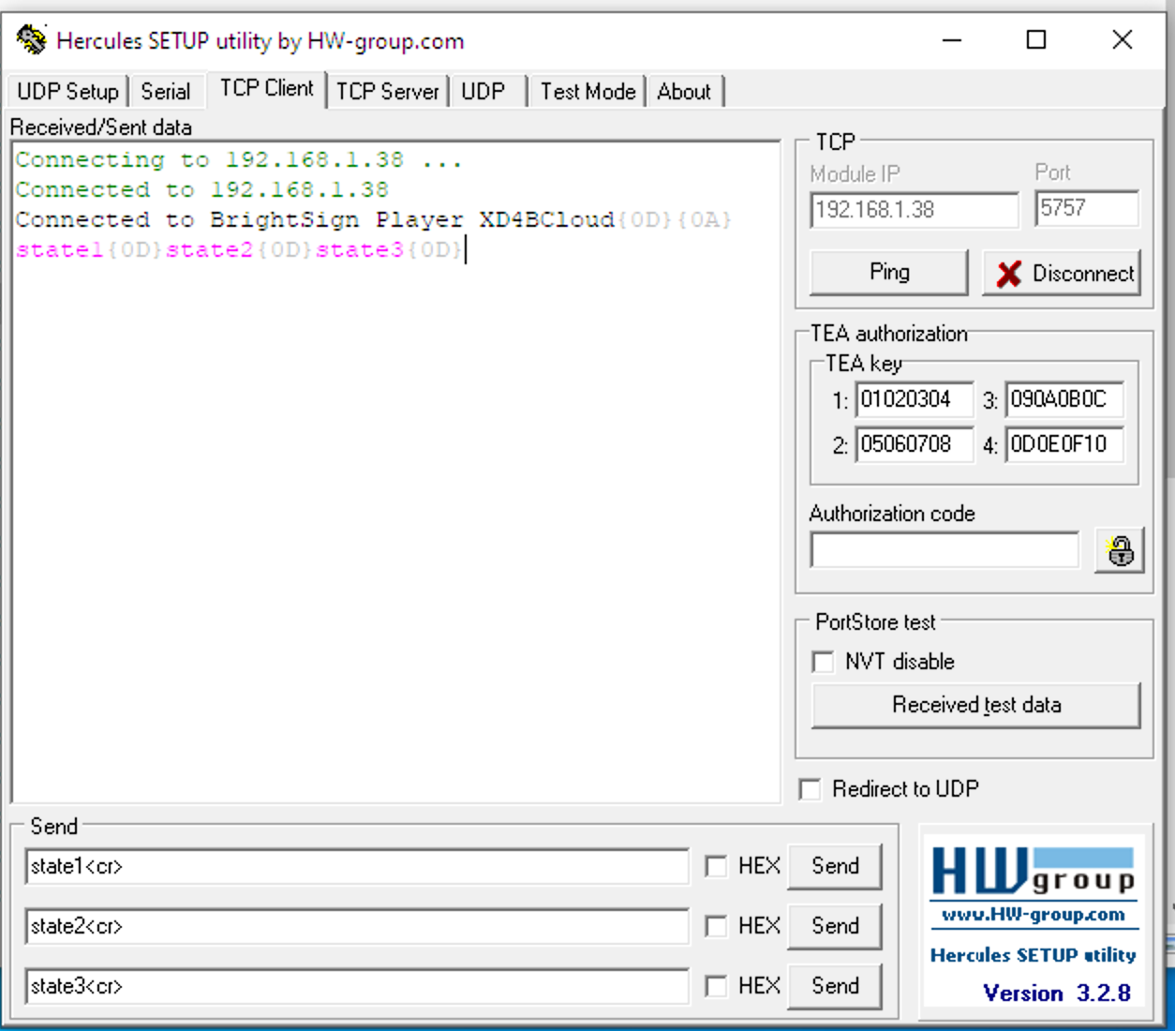

Packet Sender (Mac)

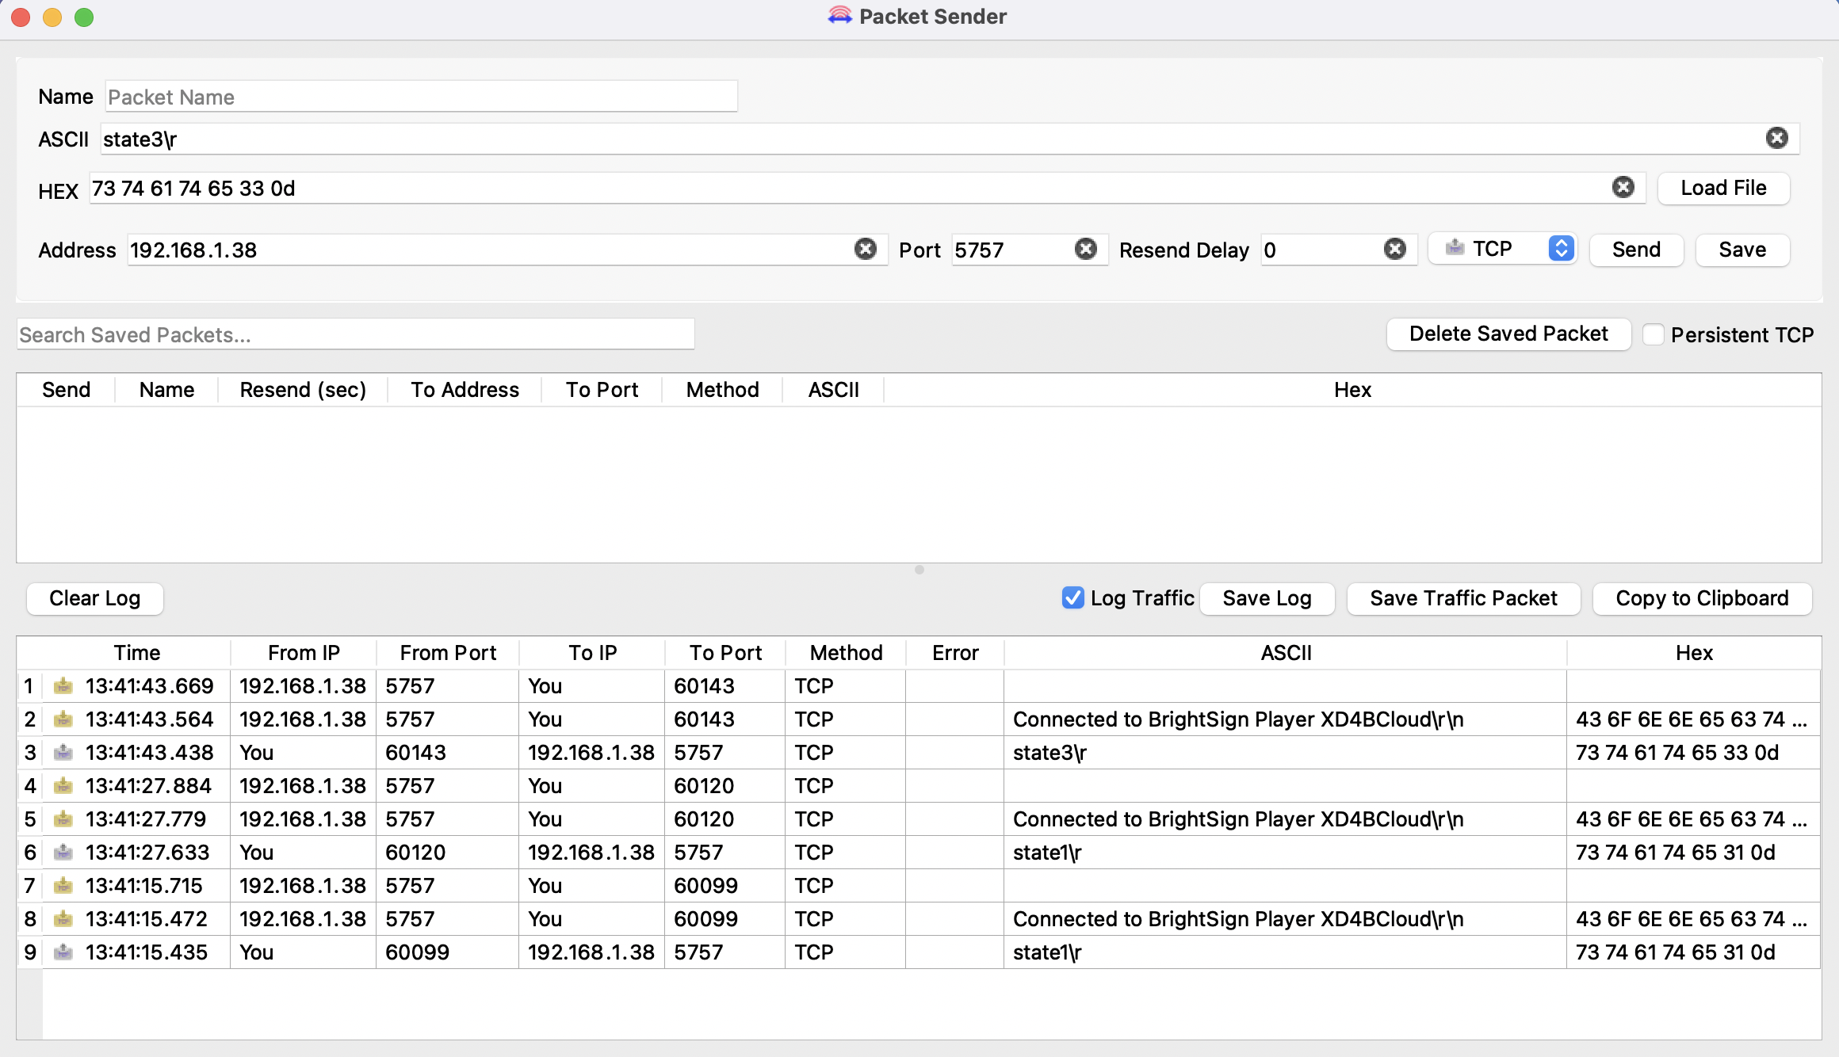

If “state3<cr>” is sent from Hercules or “state3\r” is sent from Packet Sender then the presentation should display the value of the TCP message received next to “TCP Message received label” along with the live text state content for “State3”.

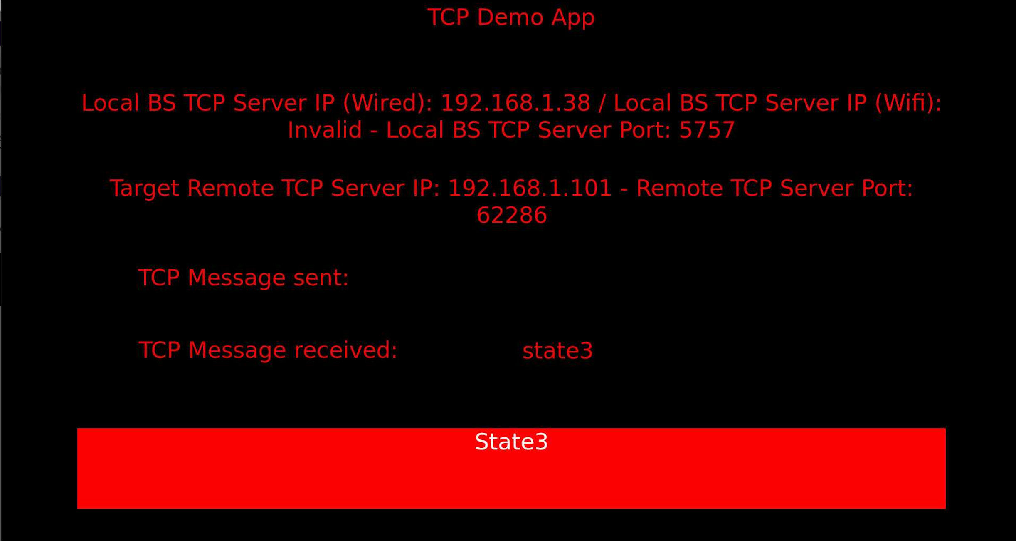

How to listen and act on a TCP Message sent to the BS player?

In order to transition from 1 state to another when the TCP message “state3” is sent to the player, a Plugin Message Event from the tcp plugin should be added between 2 states with an input value of “state3”.

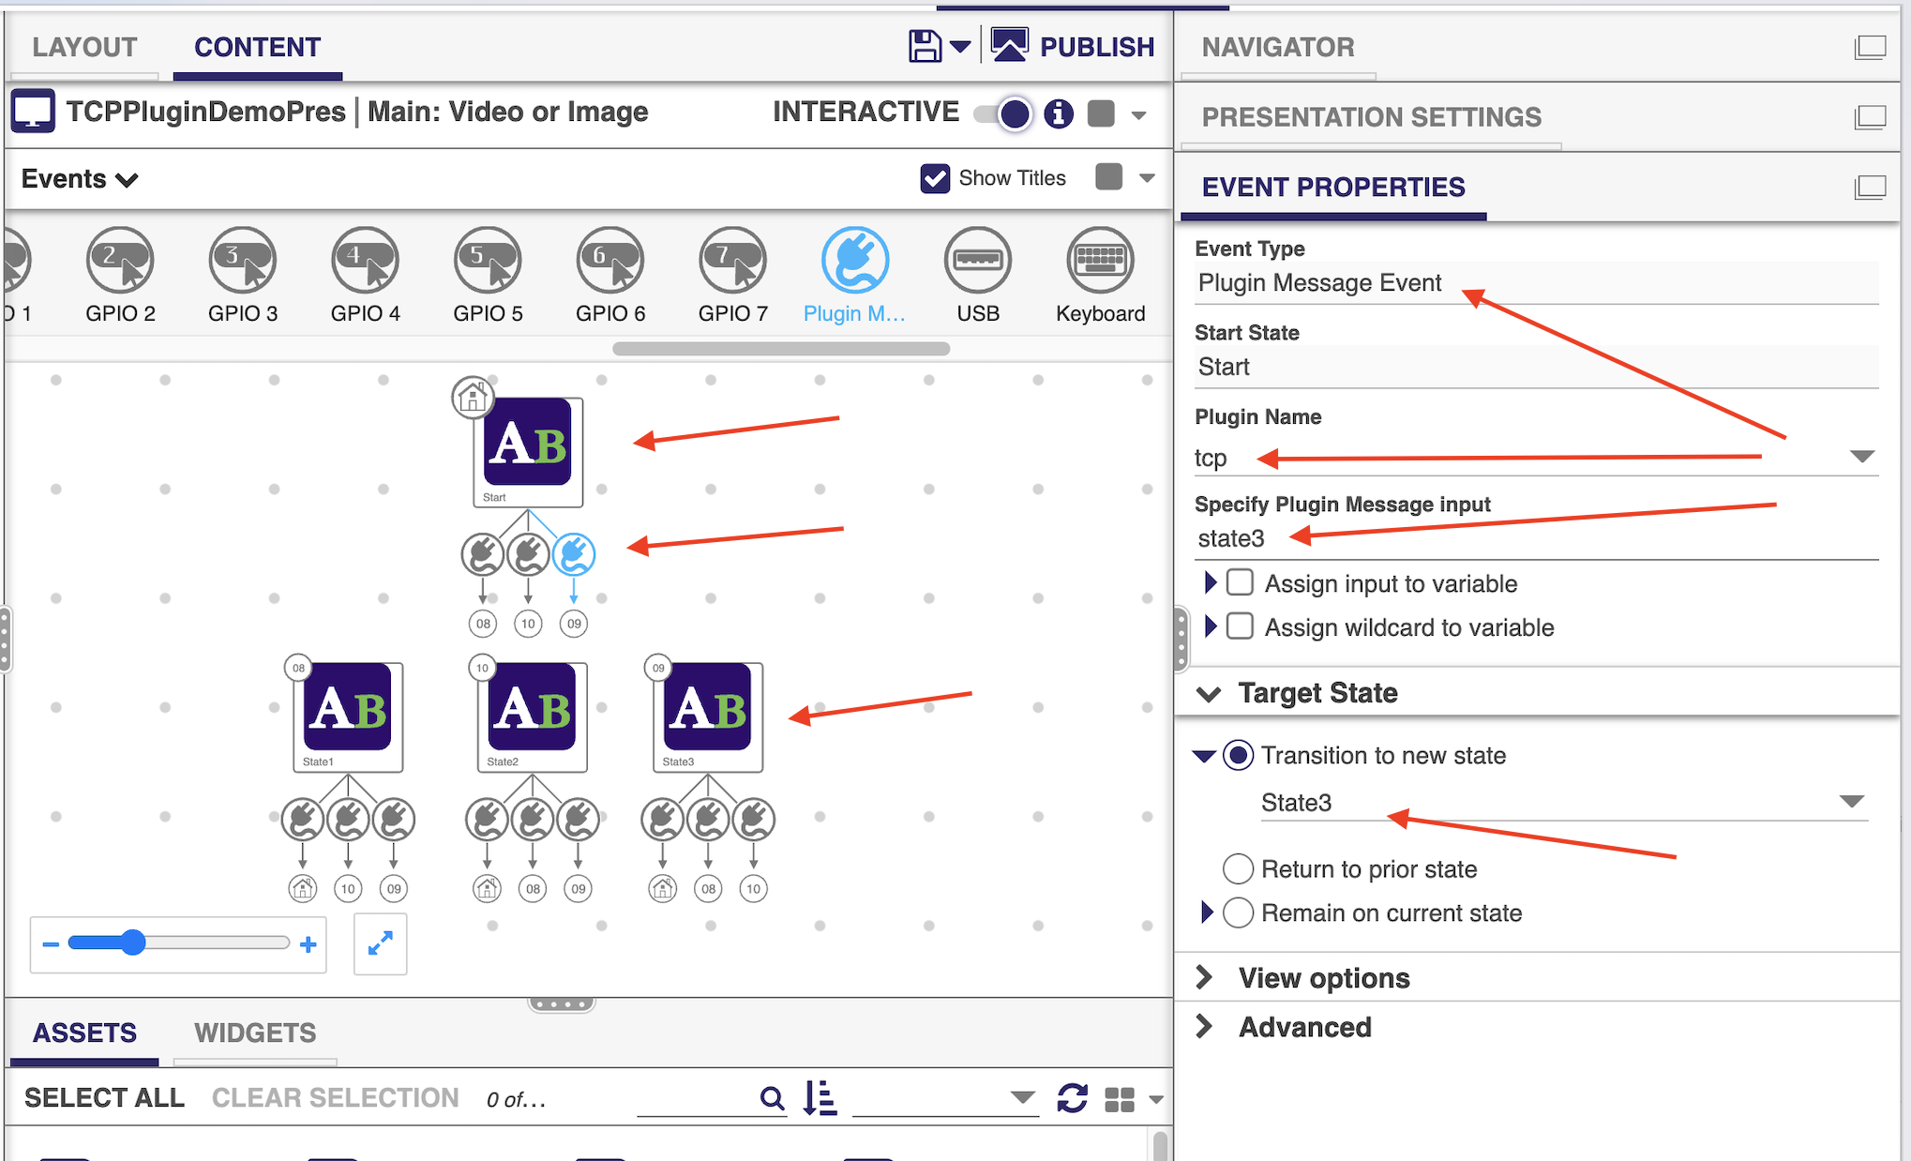

How to send a TCP Message to a remote server/device?

In order to send a TCP message to a remote server/device, add an Advance command > Send Plugin Message > “tcp” > then add “your-tcp-message” in the following format
tcpmsg!your-tcp-message – in the below example to send the “RLB” TCP message the command Parameter value was set to “tcpmsg!RLB”.

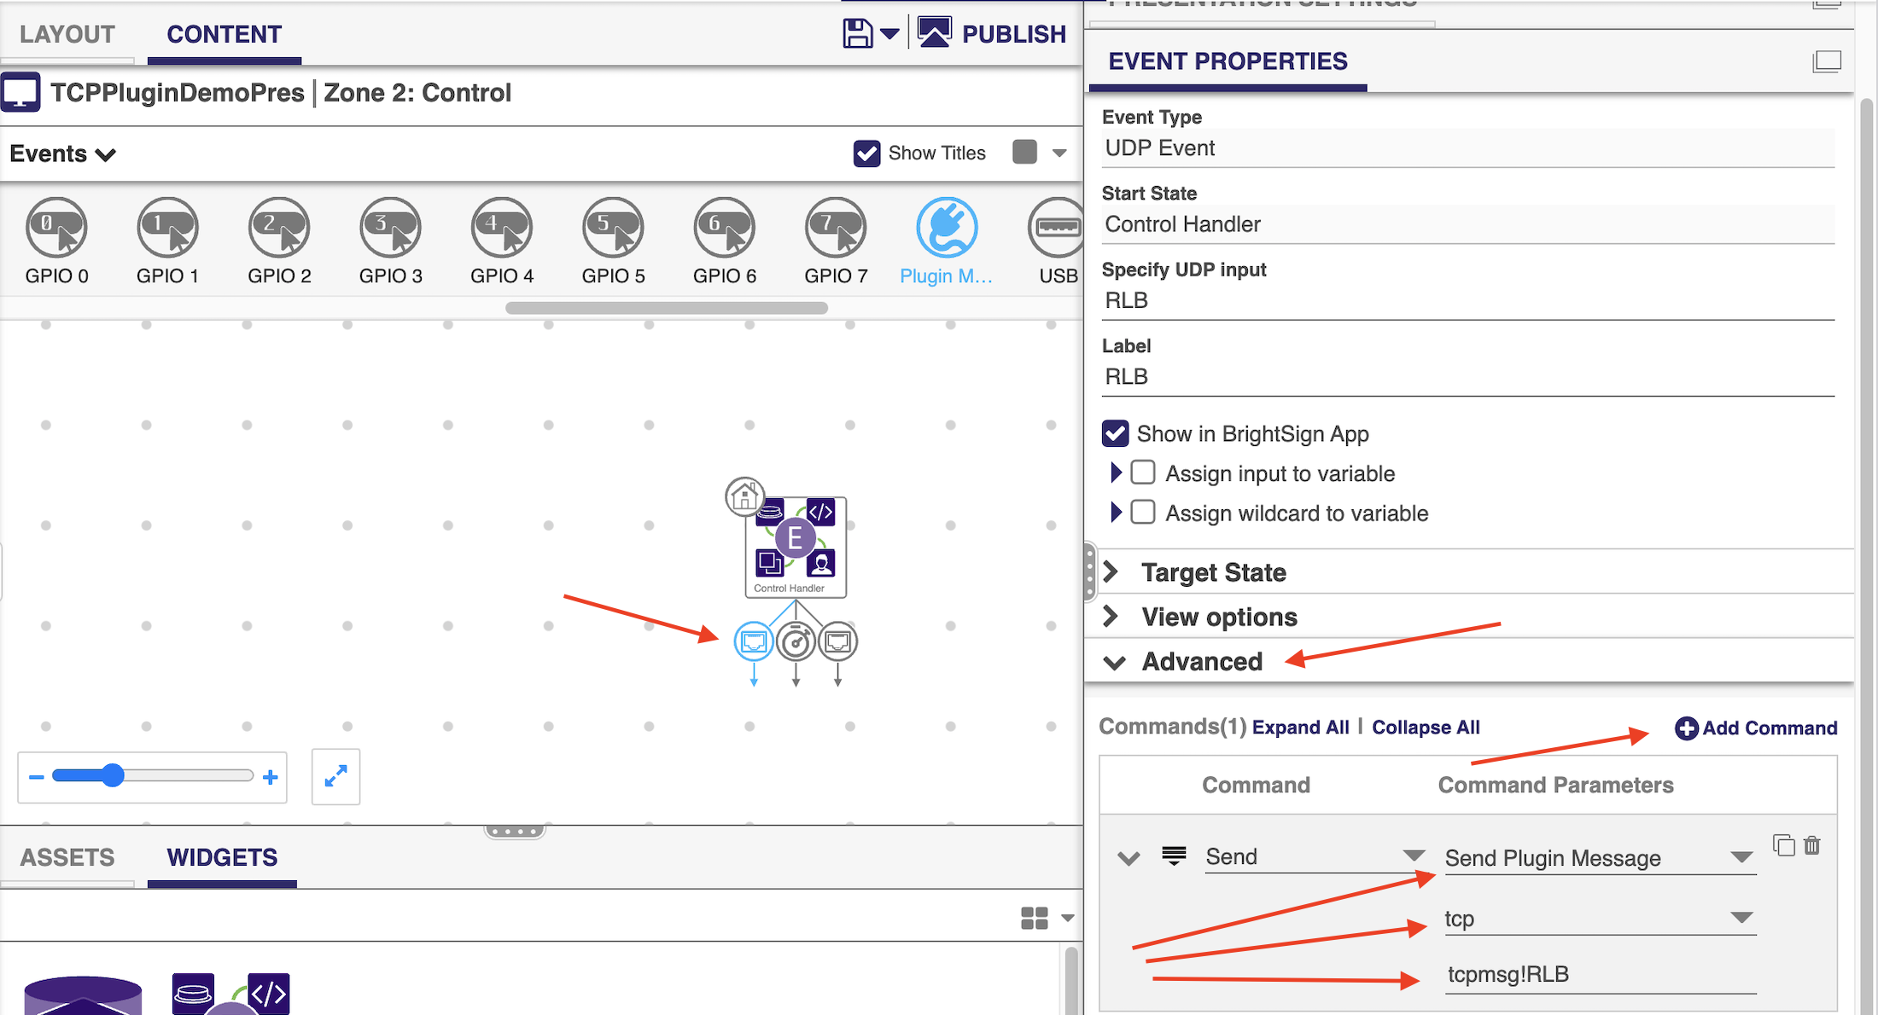

Troubleshooting:

If the presentation does not behave as expected please check the DWS logs for failures/error messages or for some clues…

For example, the below message “Failed to connect to remote server – REASON – connect: No route to host (113) will be displayed if the IP address of the server is not entered properly or isn’t reachable.

